Ideation Phase
Define the Problem Statements

Date | 18 February 2026
Team ID | LTVIP2026TMIDS65684
Project Name | TransLingua – AI-Powered Multi-Language Translator
Maximum Marks | 2 Marks

Customer Problem Statement Template:
Many individuals such as students, business professionals, travelers, and researchers struggle to understand and communicate in different languages. Existing translation tools may be slow, inaccurate, or difficult to use, and some require complex installations.
Customers need a simple, fast, and reliable web-based solution that can translate text accurately using advanced AI technology. The system should be easy to access, userfriendly, and capable of providing real-time translations without technical complications.
This problem statement helps in understanding the customer’s challenges and designing a solution that focuses on usability, speed, accuracy, and accessibility.
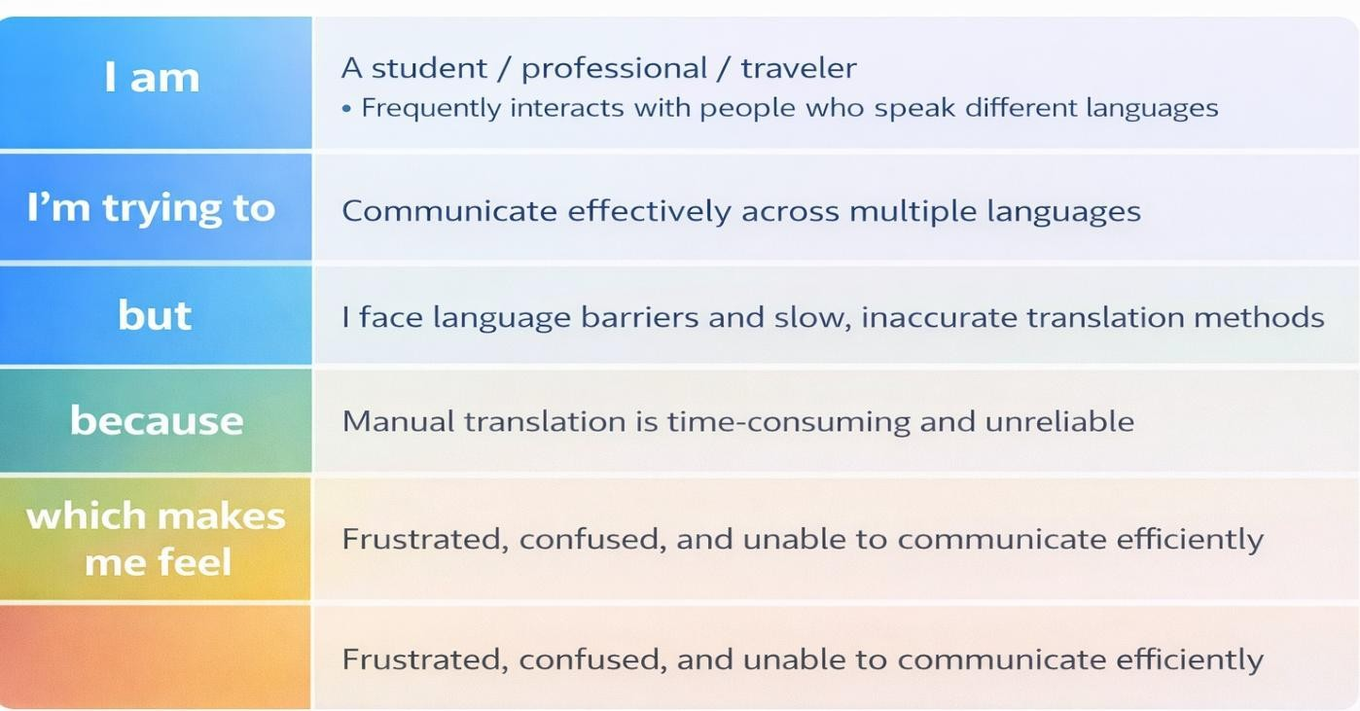
Reference: https://miro.com/templates/customer-problem-statement/
Example:
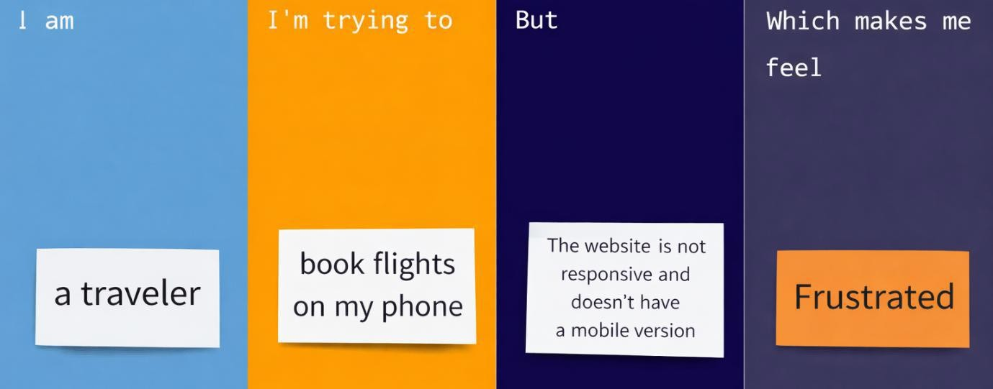
Problem  Statement (PS) | I am (Customer) | I’m trying to | But | Because | Which makes me feel
PS-1 | I am a student | I’m trying to understand study material written in another language | But I cannot fully understand the content | Because I am not fluent in that language | Which makes me feel confused and stressed
PS-2 | I am a business professional | I’m trying to  communicate with  international clients | But language differences create misunderstandings | Because translation methods are slow or inaccurate | Which makes me feel frustrated and less confident

